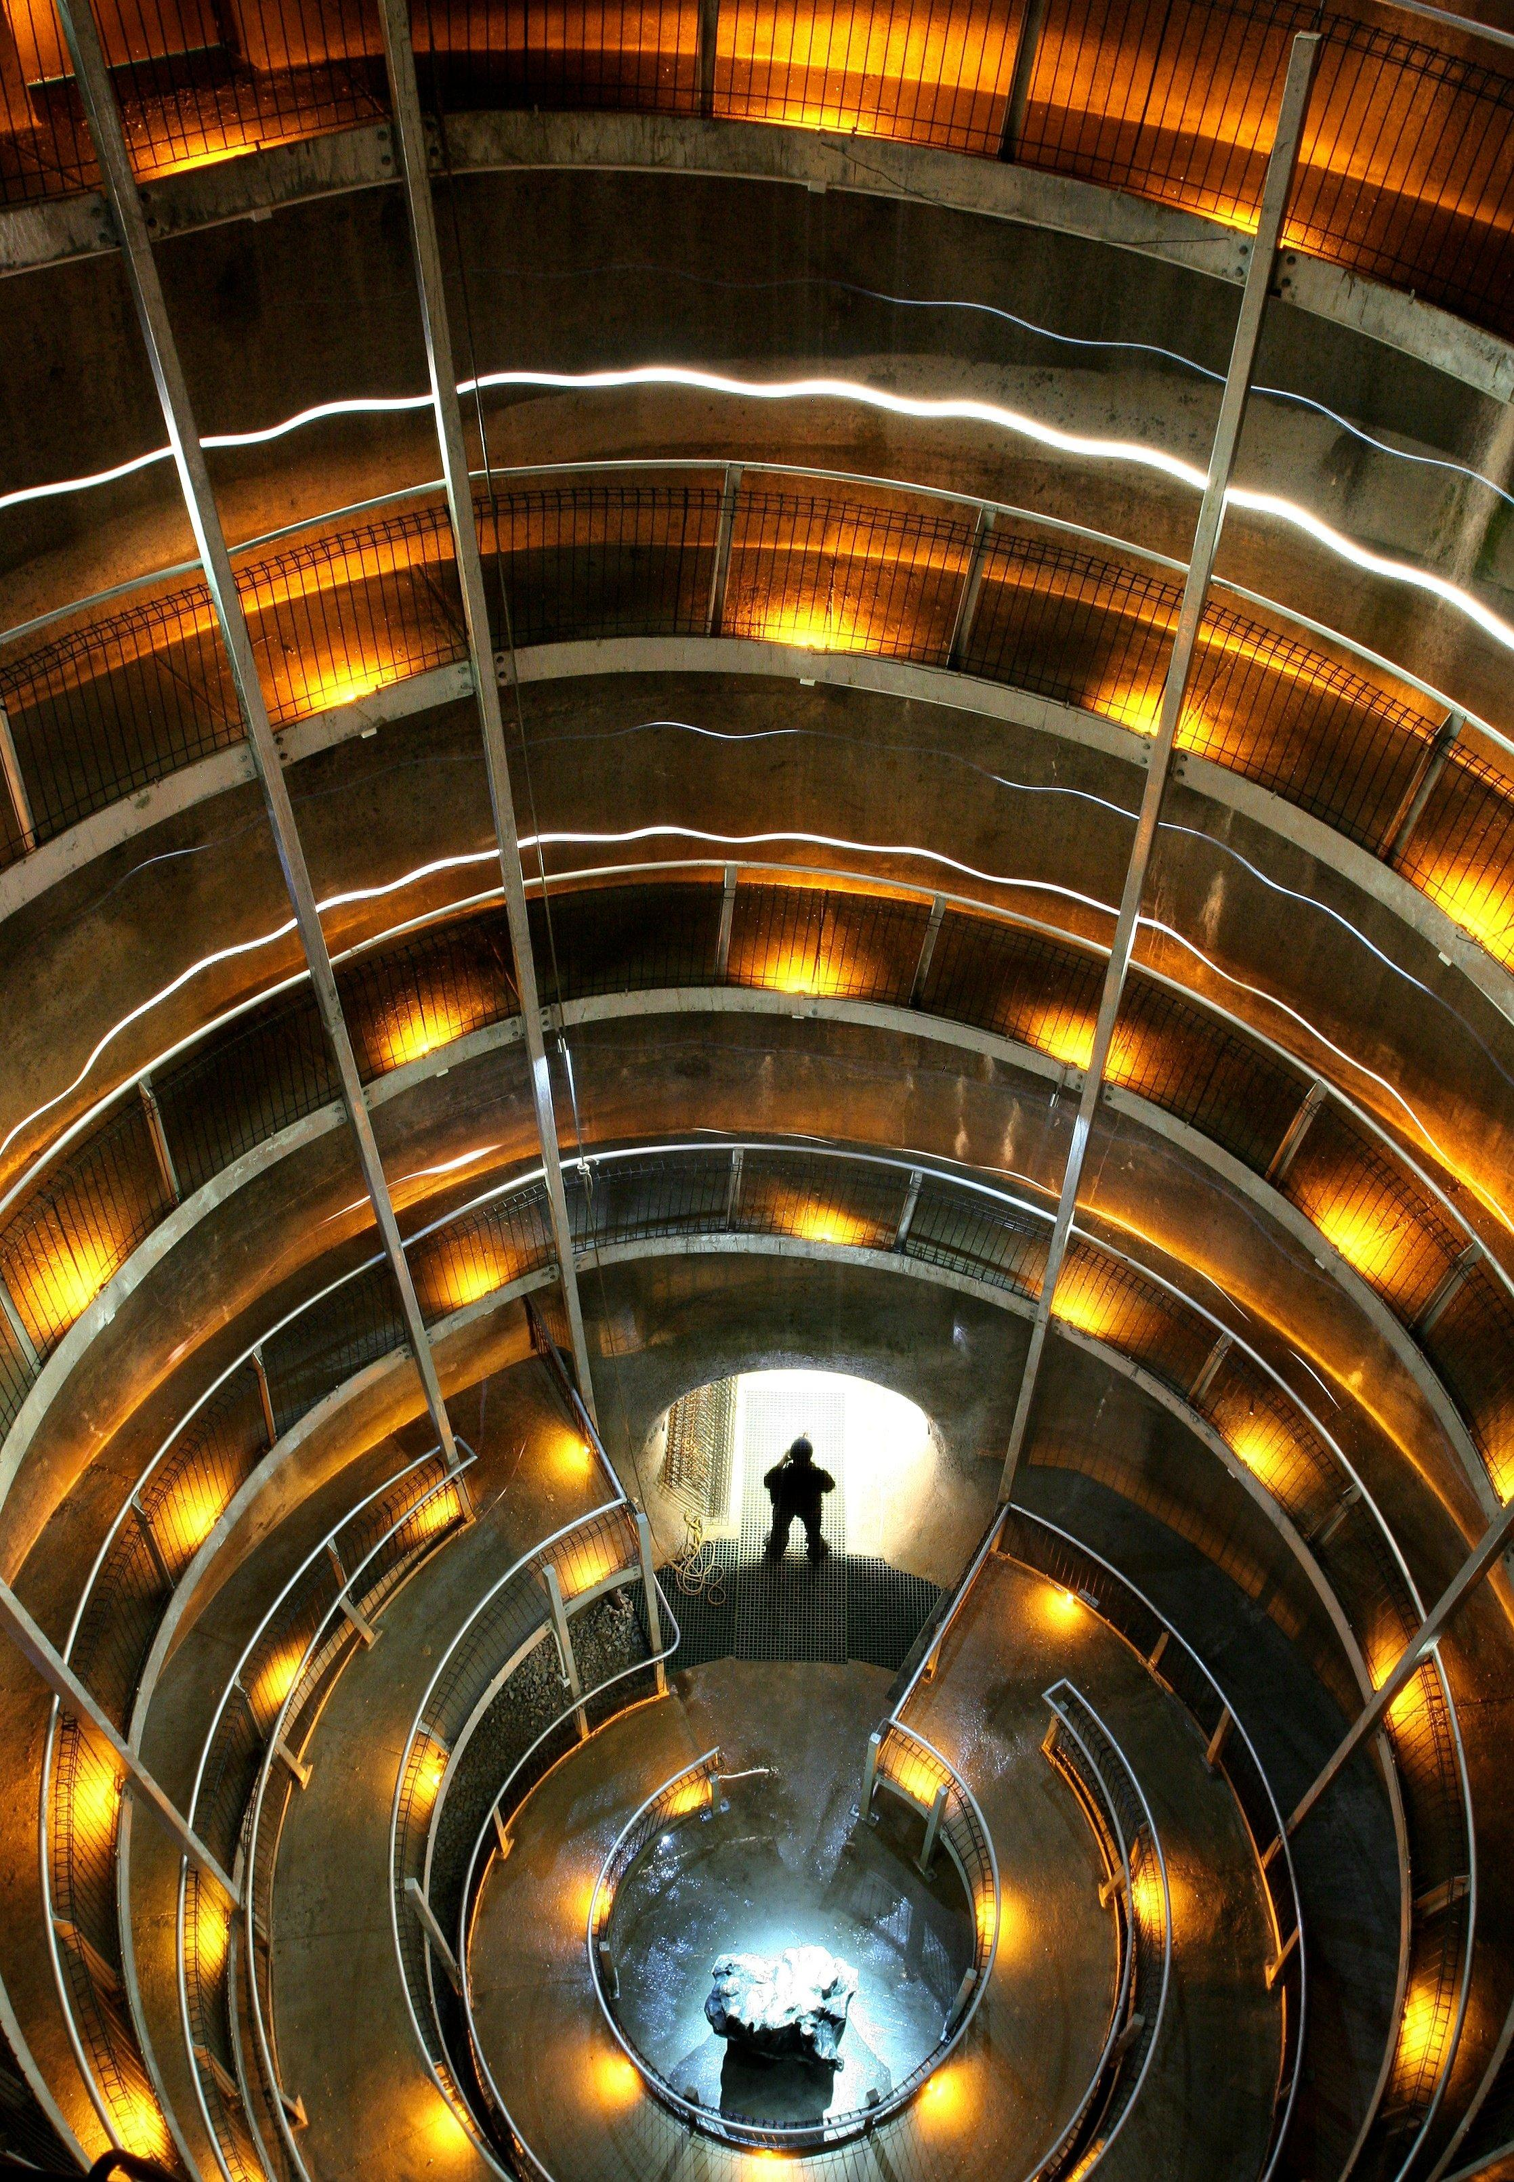
conference proceedings
1973 – 2007
conference proceedings
1973 – 2007
ackma
ackma

